[](https://www.blogger.com/blog/post/edit/1329052986263180533/3584921799568807323)

I think that I'm just going to keep going until midnight and see how far I get. I could get a few more posts out of this. what am I thinking about: The Strategic Pants reserve:

](https://www.blogger.com/blog/post/edit/1329052986263180533/3584921799568807323)

This is the pair - this is a picture of the pair of silver colored jeans that I bought when I was back in texas.

](https://www.blogger.com/blog/post/edit/1329052986263180533/3584921799568807323)

This is a picture from back when I was in texas, this - these jeans were too loose - in my mind - if i need to wear a belt - the pants are too loose - then what is a belt for? well i guess in my mind belts are ornamental. I think I threw these ones away at some point - i know i don't have them - so i must have thrown them away.

](https://www.blogger.com/blog/post/edit/1329052986263180533/3584921799568807323)

This is a picture of five pairs of the i guess - sand colored jeans i bought a while back - they are still in their original packaging.

](https://blogger.googleusercontent.com/img/b/R29vZ2xl/AVvXsEin4oRgHRiVu0dd0qGm5DZlKrUJjVLWtDI4N8IdYoeFUyKASB25tEr-kl1-mYdOGpslPKjvDz9mGLFFS7JY49tqDVi6eMR-6o9n4qlEEBTCyWvdE8-JHNxjLQ_ODZqQJ4U0ULxa7MbiUw4M-o-p737LouUfZ-HFuBx-XdRsKwTp8_dIp2wuIkrne64WIUo/s320/IMG_20241212_180624_742.jpg)

this is a picture of the two new pairs of silver colored pants I bought a while back when compared to the silver pants i bought when I was in texas.

](https://blogger.googleusercontent.com/img/b/R29vZ2xl/AVvXsEjWiycWv7ue24R5YY_QZ5Z-P-VwGD2S6_Scgndfgzk3SIJIllP8ajAb1T_dYEQctkQC-uCD_a5IrOaGe1UINGuRE8akM1n6yRt6vaPX8wGIq5YIj7FnjgmHisa7gz6g2xNUyn5J4_1HZAv6bbVWaCStAqmLPiFaS2Y1lFMtR1sPhiw0JNiVyhNv8WPuNq0/s608/1%20Self%20Portrait%20Untitled.png)

this is a self portrait - it has nothing to do with the strategic pants reserve, but I kind of like it, and i thought i would share it with you since it is me.

anyway - those are most of the files I can find related to the strategic pants reserve.

well there are actually a few more and I have a few more minutes before midnight.

[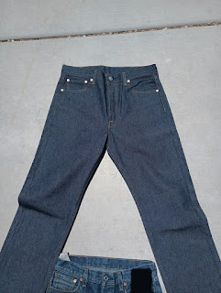](https://blogger.googleusercontent.com/img/b/R29vZ2xl/AVvXsEg9Pkefh1VSviIJisiaX2s7PJuEgXShBBJCzMXJ4LPbjLa99nAuS-b56SWCwIdO-8vYLF2YVsyFqMWN1TdaTDxAHxtJE8no0nJbazecEb8kxA1bCIFTAq-ZbnqhGoAa9pKX-nb0LsILG9g3h4JKMdCFQI6ELTVsnbRbdwUhu1jpoMuPkvIDN7OAYZ1sz6w/s796/000IMG_20230720_122549awerawer399%20(2).jpg)

so this picture was taken back in texas, it's a comparison

between an existing pair of pants, and a new pair of pants

i think the idea is to compare wear patters.

there is one thing thought - i'm not sure if the worn pair

is pre-shrunk or shrink to fit, it think it may have been

pre-shrunk.

[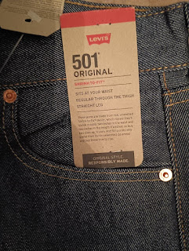](https://blogger.googleusercontent.com/img/b/R29vZ2xl/AVvXsEiHJ_P91plQKmjX3j7yX0E_uvm6NXdaSJPLU-KokLn6Dp_WSsbLhxSAnAZvxxYFKHGO7LCXU0lREixnudcbrMA3inFSKleIhhiUUHPdxqqfImdtIB8ufOVEDy4IiPz9SlN3PmlvPG_up_y1fJb8iW94S28oOmh-WjunCC_pR-nQsSnkcPZtGX-Ua5uRbZU/s796/000IMG_20230720_122120638~2.jpg)

this is another picture of new pants

[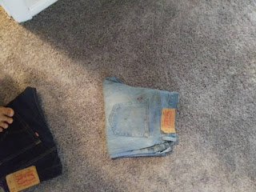](https://blogger.googleusercontent.com/img/b/R29vZ2xl/AVvXsEhJxDhc_JWy2Nhnq22F4J0T6lV2qlXpq9MKOc2Mx7kE6ATNpJRVWq9n2T5MkkFLAlftZJq6qMbiY4SyoVld1kptLkOsTnH-mXQOR5i3rkeVot3WRhOVmmns2pvV8MdBb_ieHaQJCczJ9AeuEc-7x4Dc_QgF2p_u45gh022jAvI_P_asR8SGxpFyOZq2GH8/s1080/08102023%200900%20PM%20vp264056406556050654%20(826).jpg)

i don't know where those or whatever happened to these

lighter blue jeans - i'm pretty sure that i threw them away.

[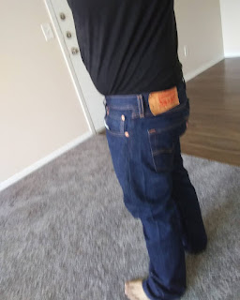](https://blogger.googleusercontent.com/img/b/R29vZ2xl/AVvXsEjZID7ALTqYxf8mObWWY1ezFTq8a81KHAtb60J5MgKPYF2MZTHysVJXlbMOHWyLsntzptsNji3t36wHv-u5I-1jWpZqtVSxdCYzCfVcQtgPTG_3wb7ZxNKsN5WR8a6GJ4bOeoHUrBb8sdv1hdFLVl12AwRF2nH3GR59bhfjM3jWqC2I1mlaoJgR0pFVnXM/s1350/08102023%200900%20PM%20vp264056406556050654%20(831).jpg)

also from when i was in texas

](https://blogger.googleusercontent.com/img/b/R29vZ2xl/AVvXsEiMoWD93XXCR96Tk3VT1HBHWhaV2rWLK2fO9WPHNxWsqRNTjlIrvu6pGE4VRO3xWBi7W4G_jG8-0ZcfA-pVWCYp0vCV6Zznmj6ltnhYRJhSjfyvaSCBmwz9gTYH0GYRxxOPvWmOvl21OHE7P9XP7bLG0ElENtB3k5S1sBGi33F673hP4BQQ2i94qeTd7Fw/s1350/08102023%200900%20PM%20vp264056406556050654%20(832).jpg)

I think that this is a pre-shrunk pair of jeans. i'm not totally sure of the sequence of some of these. like which ones preceded which, or what. but i guess that's it, and this post, # 92 should be the final post in the series.

the two pairs of silver pants I used during my business trip to kansas city, so they are now out of reserve status.